Web 2 – Final Project

Part I (70%)

Overview
You can work in groups of two for this assignment. It is also possible to work individually, but I do strongly discourage it; please talk to me about this if you are planning on working by yourself. This assignment will allow you to apply the concepts and technologies covered in class to a “real” project situation. In this project, you will design and implement a web application for a fictional travel photo sharing community site. Some parts of the site will be available to the public; other parts in the site will eventually (see Part II) only be available to site administrators. By the end of the assignment you will have a non-trivial web application that can be a tremendous portfolio piece.
If working in a group, each member needs to take responsibility for and complete an appropriate amount of the project work. Be sure to consult the instructor at least one week prior to the due date if your group is experiencing serious problems in this regard.

Deliverables Summary
You must implement the use cases described in the use case section. As well, the following nonfunctional requirements must be met in this milestone:
- The use cases must be implemented in PHP. You will be using a version of the Art database (similar to the one of your previous assignments).
- Be sure to make use of the appropriate features of PHP. Be sure to use good programming. Appropriate programming design patterns are encouraged if you completed CS III.

Submitting
Submit under Learn:
- ALL the url of the pages created by you. The links MUST be:
  - written in the text submission area and NOT in the comment area
  - written one per line with no other words preceding or following the link, and
  - linked to the page (hyperlink).
- ALL the .php files you have created zipped in a folder named FinalProject_Group# (e.g., FinalProject_Group#1).
You will lose marks if you do not follow these submission instructions.
Submit Part I and Part II separately in the appropriate area by the due time.

TimeLine and Submission Deadlines
In order to complete the project on time you must follow this timeline:
- Part I must be completed by not later than 11:59 pm, April 20th.
- Part II must be completed and submitted by not later than 11:59 pm, April 29th.
On May 6th you will discuss/present your Final Project with the instructor.

Grading
The grade for this assignment will be broken down as follows:
Usability and visual design 10%
Program design and documentation 10%
Features 80%

Database Schema
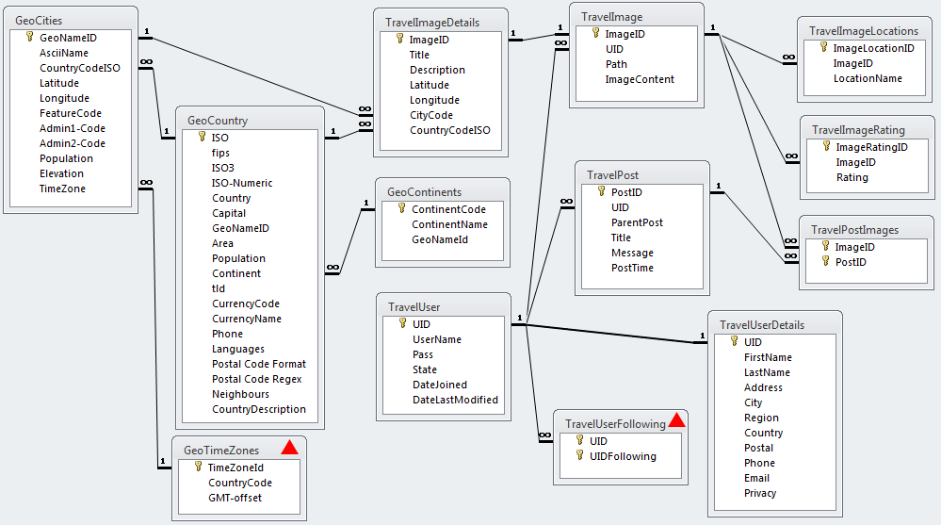

USE CASE NAME: | Bootstrap Theme and Site Design
DESCRIPTION: | Design site’s appearance by customizing Bootstrap
1. | Use the Customize facility in the Bootstrap website (http://getbootstrap.com/customize/), which allows you to create a customized CSS theme for Bootstrap.  You may want to make use of a color scheme designer such as http://colorschemedesigner.com, http://www.colourlovers.com, https://kuler.adobe.com, or http://design-seeds.com if you need help coming up with a color scheme. Your color scheme must be different from the default Bootstrap install (and different also from those available from http://bootswatch.com).  Your customized theme must use two fonts from the Google Web Fonts collection.  Some of the changes you will want to make to your site, such as header and footer treatments, will require additional CSS formatting outside of Bootstrap.  Minor style changes to the basic Bootstrap “look” will receive lower marks than those groups that make more substantial changes.

USE CASE NAME: | Home Page
DESCRIPTION: | Home page for the web site
1. | The system displays a logo and navigation system (see Navigation use case). It should also contain a carousel (see Bootstrap site) with at least three slides. Each slide should act as a promotion of what the site offers (i.e., it is marketing).  Every page should display a certain number of relevant visual boxes that contain other related data. For the home page: top images (based on ratings), new additions (assume the order of the TravelImage table is the order they have been added). From a design standpoint, these other boxes must be encapsulated as user controls.

USE CASE NAME: | Navigation
DESCRIPTION: | The web site's navigation system.
1. | The system must provide a way to navigate to different sections of the site. There should be a primary navigation system with links to Home Page, About Us, Advanced Search, and Browse. The browse must have a submenu (you can use Bootstrap’s dropdown navigation) that provides options for browsing posts, images, or users. The primary navigation must be available everywhere in the site.  There needs to be a utility menu that is available everywhere in the site. It must have links to View Favorites List, My Account, Register and Login. The last three can simply be dummy links (the next assignment will add the ability to login and register).  The system should also have a secondary navigation system that displays continents, countries and cities. The users can then click on any of these and go to either the Single Country/City or the Search Results (if continent clicked) use case. There are too many countries and cities to display all of them in the secondary navigation. Show just those that have travel images (hint SQL GROUP BY).

USE CASE NAME: | About Us
DESCRIPTION: | Display information about this site
1. | The system will display information about this site. Be sure to mention that this site is hypothetical and was created as a final project for CS 44106 - WP2 at Kent State University taught by Dr. A. Guercio. As well, be sure to list the group member names and roughly what parts of the project each member implemented.

USE CASE NAME: | Display Single Post
DESCRIPTION: | System displays a single post for view by any user.
1. | This use case is initiated when a user selects a single post to display (e.g., clicks a link that takes the user to this page).
2. | The system displays information about a single post. This page will have the functionality of Part02_SinglePost.php from Project #2, except that the user name will be a link to the Display Single User use case. There should be some way to view all the images for the post; the view and favorites links (from Project #2) should now work.  This page must allow the user to add the post to a session-based favorites list (i.e., go to the Add To Favorites use case). In this case, it will be added to the favorite posts list.  Every page should display a certain number of relevant visual boxes that contain other related data. For single post page: Other Posts By User (display other posts by the same user). From a design standpoint, these other boxes must be encapsulated as functions.

USE CASE NAME: | Display Single Travel Image
DESCRIPTION: | System displays a single travel image for view by any user.
1. | This use case is initiated when a user selects a single travel image to display (e.g., clicks a link that takes the user to this page).
2. | The system displays information about a single travel image (that is, it must start with the same functionality as your Part03_SingleImage.php from Project #2). You must also indicate any posts that this image is in. Be sure to turn data into hyperlinks when appropriate (e.g., user, city, country, post).  Instead of displaying the Latitude and Longitude location fields, you must display a Google map with a marker showing the location. Put the map within a Bootstrap collapsible accordion element (see Javascript section of Bootstrap website).  This page must allow the user to add the travel image to a session-based favorites list (i.e., go to the Add To Favorites use case). In this case, it will be added to the favorite travel image list.  In part II, you will also be integrating the ability to display and add reviews, so make sure your design can accommodate this change.  Every page should display a certain number of relevant visual boxes that contain other related data. For travel image page: Related Images (show other images that have the same country), Posts (show other images from same posts). From a design standpoint, these other boxes must be encapsulated as functions.

USE CASE NAME: | Simple Search
DESCRIPTION: | System allows user to search for travel images from a single search box.
1. | This use case is initiated when a user enters text into search box and hits some type of submit button or link. Note: this search box should be accessible everywhere in the site.
2. | The system will search for results that match the travel image title. The search should be a wildcard search (i.e., Like “searchvalue%”).  The system goes to the Search Results use case.

USE CASE NAME: | Advanced Search
DESCRIPTION: | System allows user to search for posts or travel images that match a set of criteria
1. | This use case is initiated when a user selects an advanced search link/button.
2. | The system allows the user to specify what kind of result they are looking for: post or travel image. The system will allow the user to specify different search criteria depending upon what kind of result they are looking for.  If they are looking for matching posts, then the search criteria will be: title.  If they are looking for matching travel images, then the search criteria will be: image title, city (use a drop-down of cities for which there are travel images), country (use a drop-down of countries for which there are travel images).  The user can select post criteria or travel image criteria but not both at the same time.  The system goes to the Search Results use case.

USE CASE NAME: | Search Results
DESCRIPTION: | System displays a listing of search results
1. | This use case is initiated after the user makes a search request or clicks a listing-type link.
2. | The system will display, depending on the type of search, matching posts or travel images, or both. Each result should have either the post title or travel image title as a link to the appropriate page. You must also add other information to each search result: thumbnail image (for travel image) and add to favorite links (for both).
3. | Provide the ability to change the sort order of the posts or travel images by providing option for ascending or descending.

USE CASE NAME: | Add To Favorites
DESCRIPTION: | Way to add an item to the user's favorites.
1. | Initiated when user clicks the Add item to favorites link/button.
2. | The system will add the item to the appropriate favorites (i.e., post or travel image) list and then either go to the View Favorites use case or indicate visually somehow that the item has been added to the favorites.  The favorites list only needs to last as long as that session.

USE CASE NAME: | View Favorites
DESCRIPTION: | Way to view and modify the contents of user's favorites list.
1. | Initiated when user adds an item to the favorites list, or when user clicks the view favorites link/button.
2. | The system will display a listing of the contents of each of the two favorites list (with the same behavior as the Search Results use case). Allow the user to modify the favorites list's contents (i.e., remove item).

USE CASE NAME: | Display Single User
DESCRIPTION: | System displays information for single user
1. | This use case is initiated when user selects a single user to display (e.g., clicks a link that takes one to this page).
2. | The system displays information about a single user. This includes the name, address, city, region, country, postal, phone, and email.  However, if the user’s privacy setting is equal to 2, then hide the address, postal, and phone. Instead display the message “hidden” in those fields.  Display a list of any posts by the user as well as a list of any images by the user, with the appropriate links.

USE CASE NAME: | Browse Travel Images
DESCRIPTION: | Way to browse the images
1. | Initiated when user requests a list of images.
2. | The system will display a list of images. For each image, display the title and along with a thumbnail or square version of the image. Make both the image title and image thumbnail a link to Display Single Travel Image use case.  One should be able to filter the list by continent or country. You could do this via links or via drop-down lists.

USE CASE NAME: | Browse Posts / Users [this is two use cases]
DESCRIPTION: | Way to browse the posts or users
1. | Initiated when user requests a list of posts / users.
2. | The system will display a list of posts or users. The links should go to the appropriate display single user or post page.

USE CASE NAME: | Display Single Country / City [this is two use cases]
DESCRIPTION: | System displays information for single country / City
1. | This use case is initiated when one selects a single city / country to display (e.g., clicks a link that takes one to this page).
2. | The system displays information about a single city or country. For the country: display country name, capital, area, population, currency code, description, and flag image. For the city: display population, elevation, country, and a map of the city within the country.  For each city / country, also display a list of travel images from that city / country. Be sure to include links where appropriate.

Guidance
This is a substantial part of the Final Project and your group will likely need to invest 50-70 hours into this part only. I would recommend the following process.
- This is a data-driven site, so I would recommend beginning by constructing the data access layer: you can use that provided in Lab14 (which I made visible again for your convenience) as your starting point. To begin, create data access objects for Posts, Cities, Countries, Users, and Travel Images. In the architecture you will functionalities such as GetAll() and GetByID() and additional methods that match the functionality required by the use cases. For instance, the TravelImages data access object, will also need methods such as GetForPost(), GetForUser(), GetForCity, and GetForCountry(). All these other methods are simply wrappers for different SQL statements. Some of these methods can be implemented as you need them.
- Write testers for each data access object so that you know each works as expected.
- Construct your user interface.
- Customize the bootstrap design.
- Implement the search results page.
- Add session abilities for favorites lists.
- Add mapping functionality.

Part II (30%)

Web 2 - Final Project: Finishing Touches

Overview
In this second part, you will add some finishing touches to the application created in first part.

Grading
The grade for this part of the Final Project will be broken down as follows:
Program Design + Documentation 10%
User Interface 20%
Functionality (follows requirements) 70%
Bonus marks (optional requirement) 10%

Requirements
In this second part of the project you will be modifying the first part of your project. Requirements drift is a key part of application development. The assignment must contain the following additional functionality:
- The site must supply the ability to log-in and/or register as a new user.
- After authentication, every page should display the authenticated user’s name.
- If the user has already been authenticated, then he/she should also be able to add new reviews to a travel image.
I have provided a new version of the Travel database that contains a modified TravelImageRating table that contains fields for the review plus links to the user. Please use this new version of the travel database for this part of the project.
Don’t make the user enter the review date (you can programmatically set that), and use the appropriate HTML5 control for entering a rating between 1-5. Alternately, you can use a fancy jQuery widget to enter the rating.
A user should be able to review a given travel image only once.
- All users (authenticated and non-authenticated) should be able to view the reviews for a travel image. For administrators, there must be a way to delete reviews directly from the travel image page.
- On your home page, add a box that lists the two-most most recent reviews. It should just list the review (or perhaps just the first 100 or so characters of it) and each should be a link to the relevant travel image page.
- Add one horizontal and one vertical travel-related banner ad to your site. You don’t have to create the ad; you can simply borrow one you find. They should be visible on every page.
- Allow administrators the ability to edit the TravelUserDetails table (add this as a link to the utility menu). They should be able to see a list of all users, and then be able to select a user to update. Appropriate validation (last name, city, address and country not blank, proper email) should be covered. Be sure to use the best user input types.

Optional Requirement (10% Bonus)
- Create a short portfolio Word or PDF document for this assignment. This is what a typical document might contain:
  - On the first page, briefly (one paragraph) describe the gist of this entire project, the technologies used (PHP, MyServer, jQuery, AJAX, etc), and the principal functionality.
  - Provide screen captures of each of the key pages (forget about the about page). If needs be, provide a short description (a few sentences) of the main functionality of the page, or of any special features on this page. If needs be, provide multiple screen captures of a given page if you want to show off special dynamic functionality.
  - Host this site on a live public web server or the school server. If you do, be sure to provide link in your about us page.
The point of the optional requirement is for you to have a portfolio to give to future employers or clients in the near future. Believe me, you have created something very special this semester in this project. Having a document like this is an awesome way of showing off your incredible and relevant web development skills.

